IPL Cricket Analytics — Project Report
Nov 8, 2026 · @Vishal

Executive summary
This project turned 260,920 IPL balls from 1,095 matches (2008–2024) into validated insights and a 3-page Power BI dashboard, backed by 273 automated checks; every issue they raised was fixed or documented.
The work ran in six phases: data profiling, cleaning, exploratory analysis, a MySQL database, advanced statistics and the dashboard. Every important number was calculated in at least two places and compared, for example Python against SQL in 9,014 comparisons with no differences.
The headline results:
- Scoring has jumped. The average first-innings score was 150–172 in every season to 2022, then 183 in 2023 and 190 in 2024.
- The toss barely matters. The toss winner won 50.8% of matches, which isn't statistically different from 50%.
- Chasing has a small edge. Chasing teams won 54.3% of decided matches, but only 18% of chases of 200 or more.
- The par score moved up. The first-innings score that gives an even chance rose from 170 to 183 runs.
- A prediction model was tested and not published. Its win probabilities were off by up to 8.5 percentage points on 2024 matches.

Data and tools
Two Kaggle CSV files (originally from Cricsheet) cover all 17 IPL seasons from 2008 to 2024. They join on match ID.
File | One row is | Rows | Columns
matches.csv | one match | 1,095 | 20
deliveries.csv | one ball bowled | 260,920 | 17
The original files are kept read-only. Their SHA-256 hashes are checked every time a script runs, so any change would be caught.
Tool | Used for
Python (pandas, NumPy, SciPy, scikit-learn) | Profiling, cleaning, analysis, statistics and validation
Matplotlib and Seaborn | 38 analysis charts
Jupyter Notebook | Readable walkthroughs of phases 1, 2, 3 and 5
MySQL 8.0 | Relational database with 7 tables and 8 views, and 28 SQL queries
Power BI Desktop and DAX | Star-schema dashboard with 111 measures

Method
The project ran as six gated phases. Each phase began only after the one before it passed its checks.
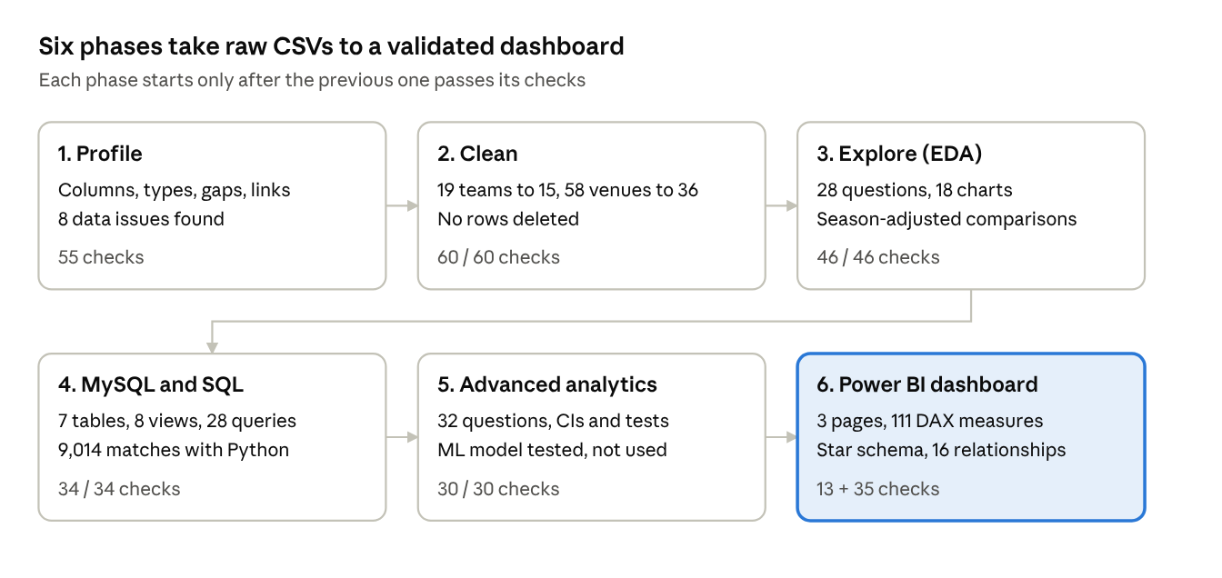
project pipeline · 6 phases
- Profile. We documented every column and found 8 data issues, including renamed teams, duplicate venue spellings, 51 missing cities, and the fact that team1 is not the team batting first.
- Clean. We merged only true renames, and checked renamed grounds against news sources before merging. Unusual but real records, such as super overs, retired hurt and 7-ball overs, were flagged rather than deleted.
- Explore. Players are ranked only above a minimum sample: 50 innings, 500 balls faced, or 1,000 balls bowled. Teams and venues are compared with the league in the same seasons.
- SQL. The data loads in one transaction that saves only if the totals match. Credentials come from environment variables, never files.
- Advanced. We used confidence intervals and statistical tests only where a difference is being claimed.
- Dashboard. The dashboard is generated by a Python script, then checked by querying Power BI's own engine with DAX.

Key findings
The IPL scores much faster now than in its first 15 seasons, while winning the toss still makes almost no difference.
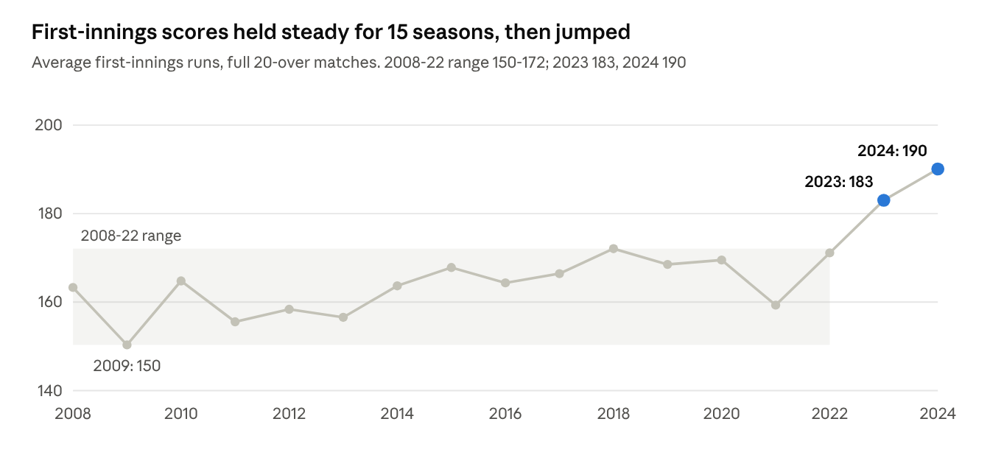
reports/eda_tables/season_summary.csv · 1,061 full matches, 2008-2024
The run rate rose in all three phases between 2022 and 2024. The biggest rise was in the Powerplay (7.82 to 9.46 runs per over), so the increase isn't limited to the end of an innings. Wickets did not become rarer, which fits more aggressive batting.
Area | Finding
Toss | The toss winner won 50.8% of 1,090 decided matches (95% CI 47.9–53.8%), which isn't statistically different from a coin flip
Chasing | Chasing teams won 54.3%. They win 83% of chases of under 140 but only 18% of chases of 200+.
Par score | The first-innings score that gives an even chance rose from 170 (2008–22) to 183 (2023–24). The 95% interval for the rise is +1 to +26 runs.
Match pressure | After 10 overs, needing 8–10 an over, chases were won 67% of the time with 8–10 wickets in hand and 42% with 5–7
Teams | Mumbai Indians have the most wins (144). Chennai Super Kings have the best win % among teams with 10+ seasons (58.2%).
Close matches | No team's close-match record differs from chance (chi-square p = 0.13)
Batting | V Kohli leads with 8,004 runs, matching the official published total. KL Rahul has the best average with 50+ innings (45.47).
Bowling | YS Chahal has the most bowler-credited wickets (205). Adjusted for season and phase, SP Narine is the most economical death bowler.
Venues | Differences in chasing success between venues are not statistically significant (p = 0.61)
All findings describe patterns in historical data, not causes.

The dashboard
The Power BI dashboard has three pages and a hidden player-detail page, all built only on validated data.
It uses a star schema:
- Four fact tables: ball, batting innings, team-match and match.
- Five dimensions: season, team, venue, player and phase.
- 16 one-way relationships.
A player or team can bat or bowl, so bowling measures switch to a separate "bowling" relationship. The design uses the project's six-colour palette, and every colour was checked for readability.

Page 1: IPL overview
Use the season range slider and the venue picker at the top right. The page shows:
- Six headline cards: matches, seasons, runs, bowler wickets, average first-innings score and runs per over.
- Run rate by season and phase.
- Average first-innings score: hover a bar to see the change from the previous season.
- Wins by franchise: hover to see win %, seasons and titles.
- Batting first vs chasing: win % by season.
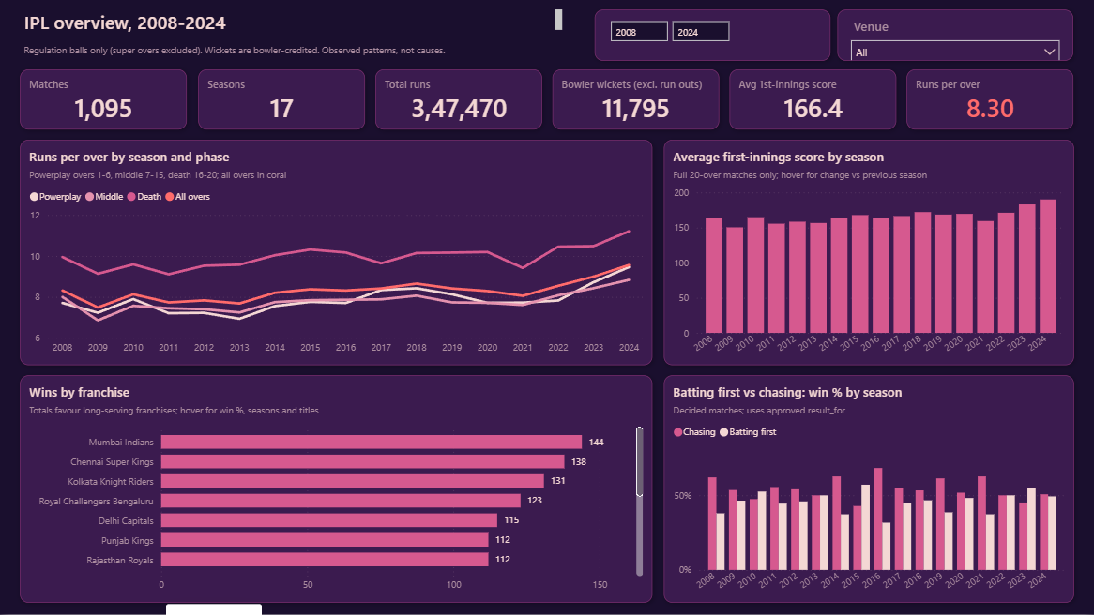

Page 2: Player performance
Pick a season and a franchise, then choose any two players as Player A and Player B to compare them side by side. The page shows:
- Top 10 run scorers and wicket-takers: these update with the filters.
- Leader tables: list only players who meet the sample thresholds.
- Average vs strike rate: a scatter of qualifying batters.
- Drill-through: right-click any player and choose Drill through, then Player detail, to see their record season by season.
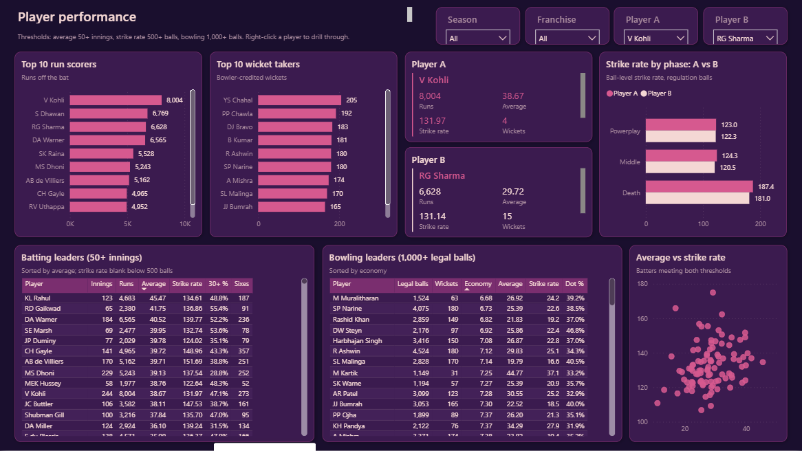

Page 3: Match and team insights
Use the season range and the venue picker. The page shows:
- Toss impact: separate figures for choosing to field and choosing to bat.
- Team strength: batting against bowling, both compared with the league.
- Chase success by target size: hover for the number of chases and the 95% interval.
- Scoring by wickets already lost: shown within each phase.
- Team phase strengths and venues: venues with 20+ matches.
- Close-match win %: by franchise.
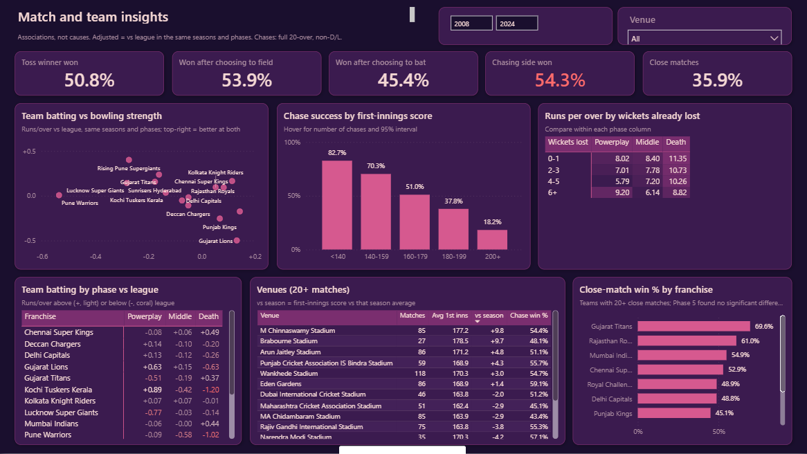

Validation and quality
Every phase ended with automated checks. The key results were compared across Python, SQL and Power BI, and none disagreed.
Phase | Checks | Result
1. Profile | 55 | 47 passed or informational; 8 data issues found and fixed in Phase 2
2. Clean | 60 | 60 passed: same rows and totals before and after
3. EDA | 46 | 46 passed
4. SQL | 34, plus 9,014 SQL vs Python comparisons | All passed, 0 differences
5. Advanced | 30 (4 against MySQL) | 30 passed
6. Dashboard | 13 export + 35 DAX checks | All passed
Two results were also checked against public records: Kohli's 8,004 runs, and the list of IPL champions from 2008 to 2024. Both match.
Mistakes caught and fixed during the work:
- A broken dashboard formula. After a column rename, a formula still used the old name. The batting-first and chasing win % measures, and the venue table that depends on them, failed. Every measure is now tested automatically.
- Overstated wording. Some draft sentences said more than the numbers supported. For example, one correlation was called "weak" when it was moderate, and one claimed two intervals didn't overlap when they did. All were rewritten from the computed values.
- Blank titles. The Titles measure showed blank instead of 0 for four franchises.

Decisions and limitations
The guiding choice was to keep the data honest: flag instead of delete, verify instead of assume, and publish only what passed its checks.
Decision | Why
Keep super overs, retired hurt and 7-ball overs, flagged | They are real records; deleting them would change the history
Merge only true team renames | Deccan Chargers and Sunrisers Hyderabad are different franchises
Use result_for for batting first vs chasing | Under the rain rule, a chasing team can win "by runs" (6 matches)
Minimum samples before ranking players | A short career can produce extreme averages by chance
Compare against the league in the same seasons | Scoring changed sharply between 2008 and 2024
Do not publish the win-probability model | On 2024 matches it was off by 8.5 percentage points, and its calibration-error interval exceeded the limit
CSV extracts for Power BI instead of live MySQL | No credentials stored in the report; the numbers were checked against MySQL
Limitations:
- Missing matches: matches abandoned before a ball are absent.
- Missing context: the data has no player role, batting position, bowling type, pitch or home-team field.
- Fours and sixes: counted from 4 or 6 runs scored, because there is no boundary flag.
- Recent seasons: 2023–24 covers only two seasons, so recent trends are less certain.
Next steps:
- ☐ Save the .pbix from Power BI Desktop (File → Save as)
- ☐ Rerun the model audit when 2025 data is added; a model calibrated for the new scoring levels may then be publishable
- ☐ Add player metadata (role, batting position) to separate openers from finishers

